Institution's Innovation Council
Saurashtra University

Business Model Canvas (BMC)

23 May 2022
At
Seminar hall, Department of Pharmacy
Saurashtra University Campus, Rajkot
Contents
Saurashtra University – IIC 2
Event Schedule 2
Event Registration Link 2
Brief about Event 3
Key Points 3
Outcome 3
About the Speaker/Chief Guest 4
Connect Us: 6

Saurashtra University – IIC
The university is dedicated to instruction, research, and extending knowledge to the public (public service). Ministry of Education (MoE), Govt. of India has established ‘MoE’s Innovation Cell (MIC)’ to systematically foster the culture of Innovation among all Higher Education Institutions (HEIs). The primary mandate of MIC is to encourage, inspire and nurture young students by supporting them to work with new ideas and transform them into prototypes while they are informative years. Saurashtra University is one the Organization that have constituted the IIC to foster the vision of MoE and be a part for the promotion and development of innovation ecosystem.

Event Schedule

02:45

Welcome

02:50

Awarness Session

04:15

Q n A

04:30

Closing Ceremony

Event Registration Link

bit.ly/BMC-SUSEC

Brief about Event
We had organized the Session on "Business Model Canvas” at Saurashtra University, Rajkot to give broad idea about Business Model Canvas and idea about different template for developing new business model.
This was an exclusive event for start-ups, students and new age entrepreneurs from the Gujarat start-up ecosystem to arrive at one place, dish out their entrepreneurial endeavours and experience the technique of Business Model.
The seminar’s objective was to gain insights in a start-up thinking process to carry out some form of start-up. Motive behind Business Model Canvas is to start entrepreneurship, by developing a product. By doing this practice, Students got the idea about how to represent their product in market, how it is different from conventional product, what is the market requirement & resources available in market.

Key Points

During the session, below mentioned points were discussed:
- What is BMC
- Use of canvas
- Key activities
- Value proposition
- Key resources
- Customer relationship
- Customer segment
- Channel
- Cost structure
- FAQs related to Business Model Canvas

Outcome

As per the event, various types of Business Model Canvas and Ideation was understood by the speaker. Students learn a lot about Business Model Canvas and how to start-up business as per resources, how to find customer needs with various examples. Business model canvas will be helpful to students to embark entrepreneurship.

About the Speaker/Chief Guest

Mr. Jayson Ganatra

Founder, Sattardas
Rajkot.

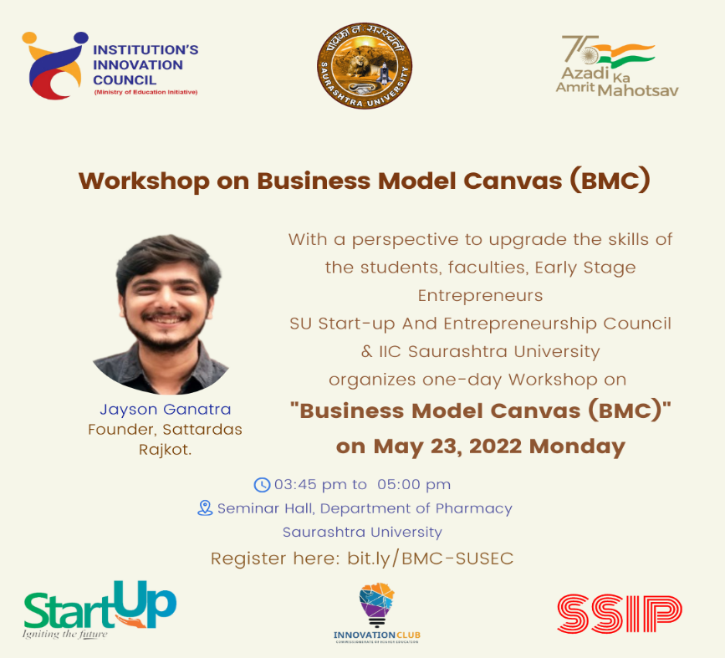

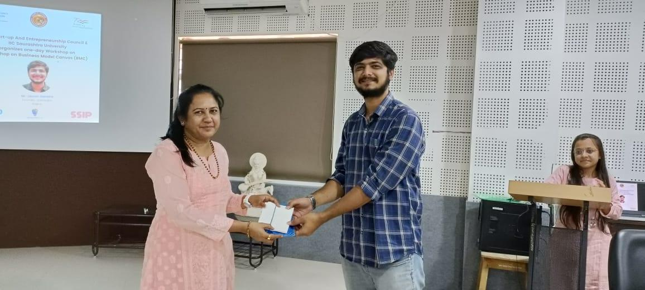

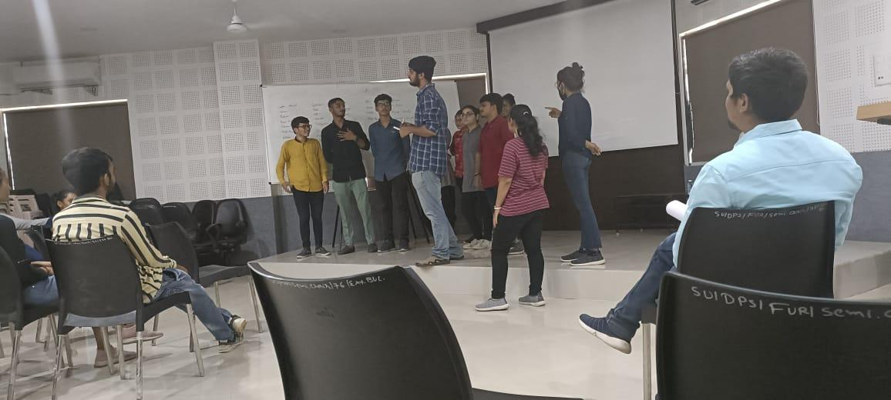
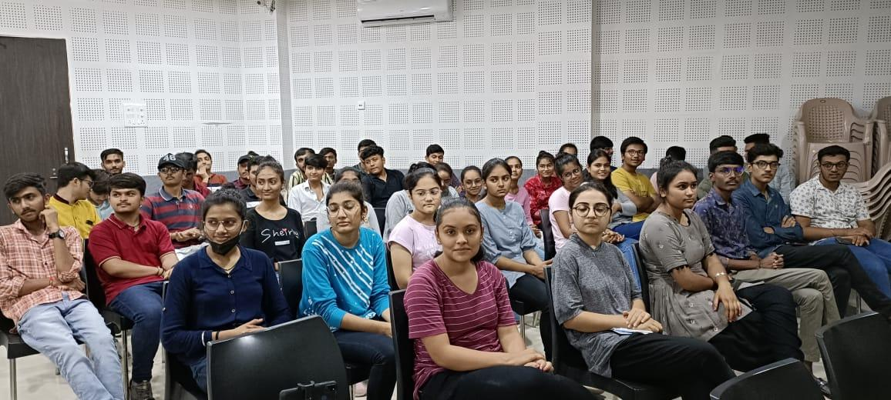
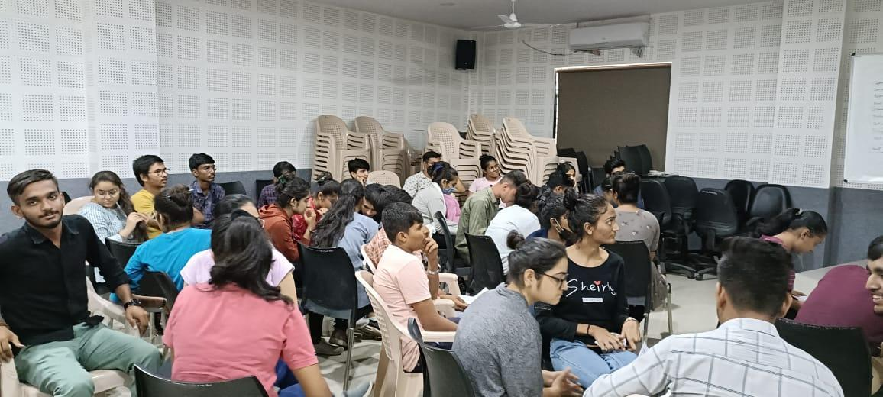
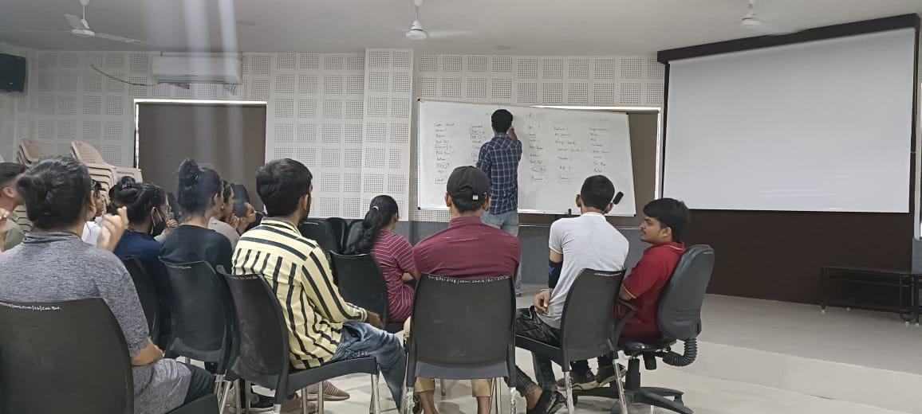

Connect Us:

https://www.linkedin.com/company/susec iic@sauuni.ac.in
https://www.facebook.com/iicsauuni bit.ly/SU-SSIP Location
https://www.instagram.com/susecrajkot https://bit.ly/SUSEC-youtube

